Bulk Flattening

Setup and Instructions

Setup

1. Install PDF 995
   1. Also make sure it is authorized
2. Create a “Bulk Flatten” folder
   1. The location of the folder is not important but once created it should not be moved
   2. My default location is to create it in “My Documents” and then to create a link on the desktop
3. Replace the default pdf995.ini file with the provided one
4. Modify the pdf995.ini file
   1. The file contains the information below. The text in green need to be modified so that they match the location and name of the user’s bulk flatten folder.

[Parameters]

Install=1

Quiet=0

Use GPL Ghostcript=1

Document Name=0006_1842285us1_rbrf_071812.pdf

User File=C:\Users\Katy Grinnel\Bulk Print

Initial Dir=

Launch=C:\Users\Katy Grinnel\Bulk Print

Autolaunch=0

Output File=SAMEASDOCUMENT

Output Folder=C:\Users\Katy Grinnel\Bulk Print

Bookmark File=bookmarks

PDF LEVEL=1.5

Conversion Parameters=-sDEVICE=pdfwrite -q -dPDFSETTINGS=/prepress -dCompatibilityLevel=1.5 -sPAPERSIZE=letter -dNOPAUSE -dBATCH

Additional Conversion Parameters=

Stationery File=Stationery

Size=letter 8.5 11.0

1. This will make it so that any document printed to PDF 995 will always appear in the “Bulk Flatten” folder. The user will never be prompted for a file name or destination
   1. It is important that this is understood as often users are confused and don’t know where their non-bulk flattened files are going

Bulk Flattening Instructions

1. Bulk download references from FIP
2. Copy references from .zip file to Bulk Downloads folder
3. Run SideBar
   1. In SideBar click Toolbox
   2. In SideBar click IDS Tools
   3. In IDS Tools Enter the Matter #
   4. In IDS Tools click “Get References”
   5. In IDS Tools make sure that the “Bulk Downloads” folder has been identified
      1. This should happen by default but often does not if the bulk download folder is not in the correct place or named correctly. For this to work the bulk downloads folder must have this exact path: c:\users\USERNAME\documents\bulk downloads

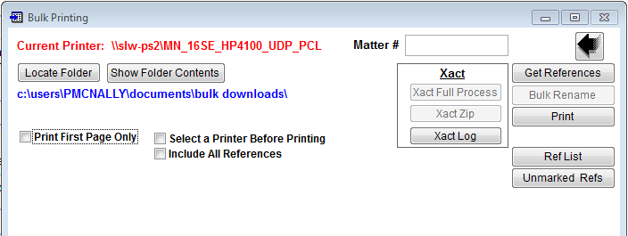

* 1. In IDS Tools click “Bulk Rename”
  2. Exit SideBar

1. Click “Start”
   1. Click Devices and Printers
   2. Make sure “PDF 995” is set to default printer
2. Close all open Adobe Acrobat windows
   1. If Adobe Acrobat was open before the default printer was changed then it will still print to the previously selected printer. By closing all windows this ensure the documents are printed to PDF 995
3. Open “Bulk Flatten” folder and make sure it is empty
   1. Any files left in the folder will get mixed with the new files
4. Open “Bulk Downloads” folder
   1. Select all files
   2. Right click the selected group
   3. Click Print
5. Wait
   1. This process can take a while. Keep an eye on the ”Bulk Flatten” folder while it continues.